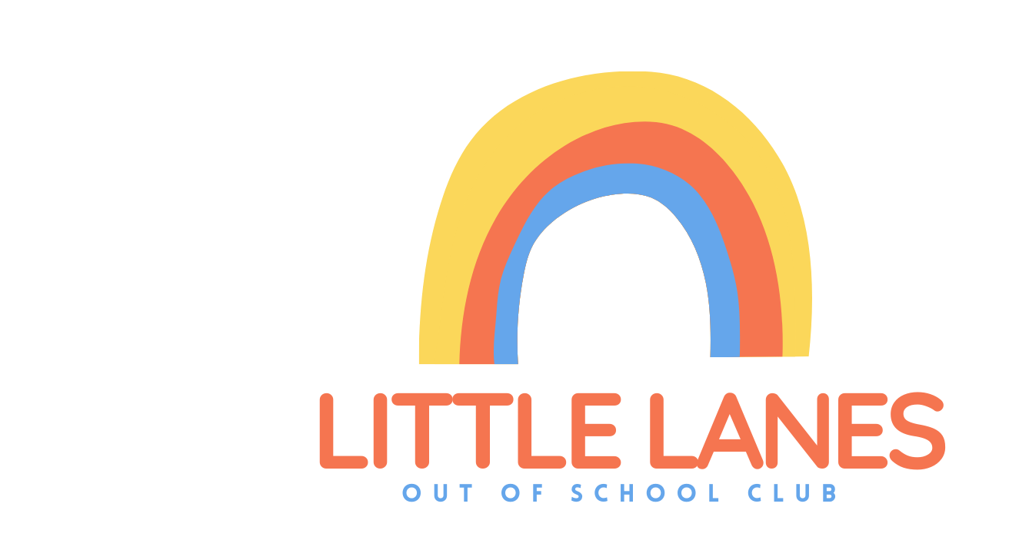
SUMMER BOOKING FORM - LITTLE LANES MEMBER ONLY

PARENT/GUARDIANS NAME AND CONTACT NUMBER: __________________
CHILDS NAME: ______________________

PRICES
GREEN LANES STUDENTS 8:30 - 5:30 £33 (£30 PER SIBLING/FRIEND) FULL WEEK £150
NON GL STUDENTS 8:30 - 5:30 £35 (£30 PER SIBLING/FRIEND) FULL WEEK £160

Please tick days you’d like to book

Monday 29th July |  | Tuesday 30th July |  | Wednesday 31st July |  | Thursday 1st August |  | Friday 2nd August
Monday 5th August |  | Tuesday 6th August |  | Wednesday 7th August |  | Thursday 8th August |  | Friday 9th August
Monday 12th August |  | Tuesday 13th August |  | Wednesday 14th August |  | Thursday 15th August |  | Friday 16th August

Invoices will be sent via text from Cheri.

- Neither mine or my child's details (including allergies and SEN) have changed since signing up for playscheme.
If they have, please download and complete a new application form.

PARENT/GUARDIAN DATE

___________________ ____________________

