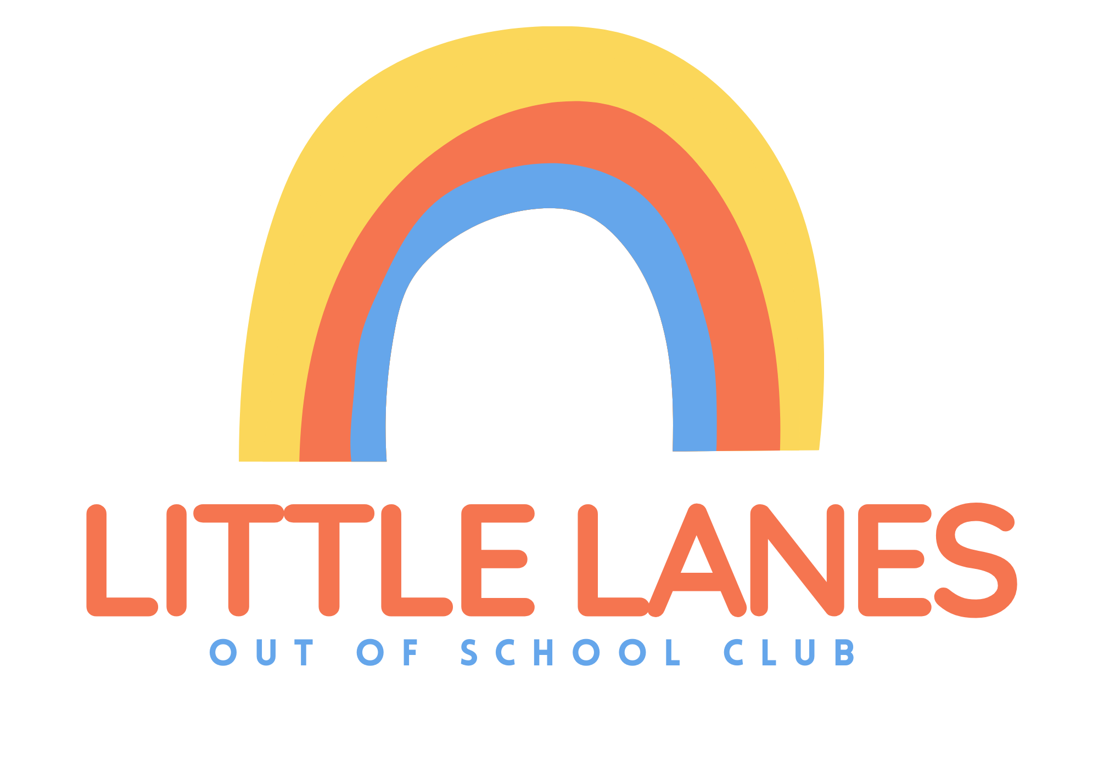

Little Lanes end of year party booking form - £10 each
13th December 2024 at Little Lanes dining hall 3:10-5:45.
Please return this form along with an envelope with your child's name on and payment in.

Childs name
Childs year/class
Does your child have any allergies
I agree to my child having photos taken at the party | YES/NO
I agree to photos being used on Little Lanes website and social media | YES/NO
I have read over the menu for the party and agree for my child to eat. | Please sign here

Little Lanes end of year party menu
Margarita pizza (non-dairy alternative for children with allergies)
Vegetable and fruit platter
Chocolate biscuits
Ready salted crisps
Cup drink - Juice

If your childs never been to little lanes please fill in the below.
Parent or guardian's name
Parent or guardian's contact number
Emergency contacts details

BUY A GIFT - £2 each

CHILDS NAME______________
Total number of gifts _________
Names + Ages of each recipient

NAME | AGE

RAFFLE - £1 strips

I would like _____ raffles please.

***Profits from our raffle and buy a gift will be split between multiple charities.

